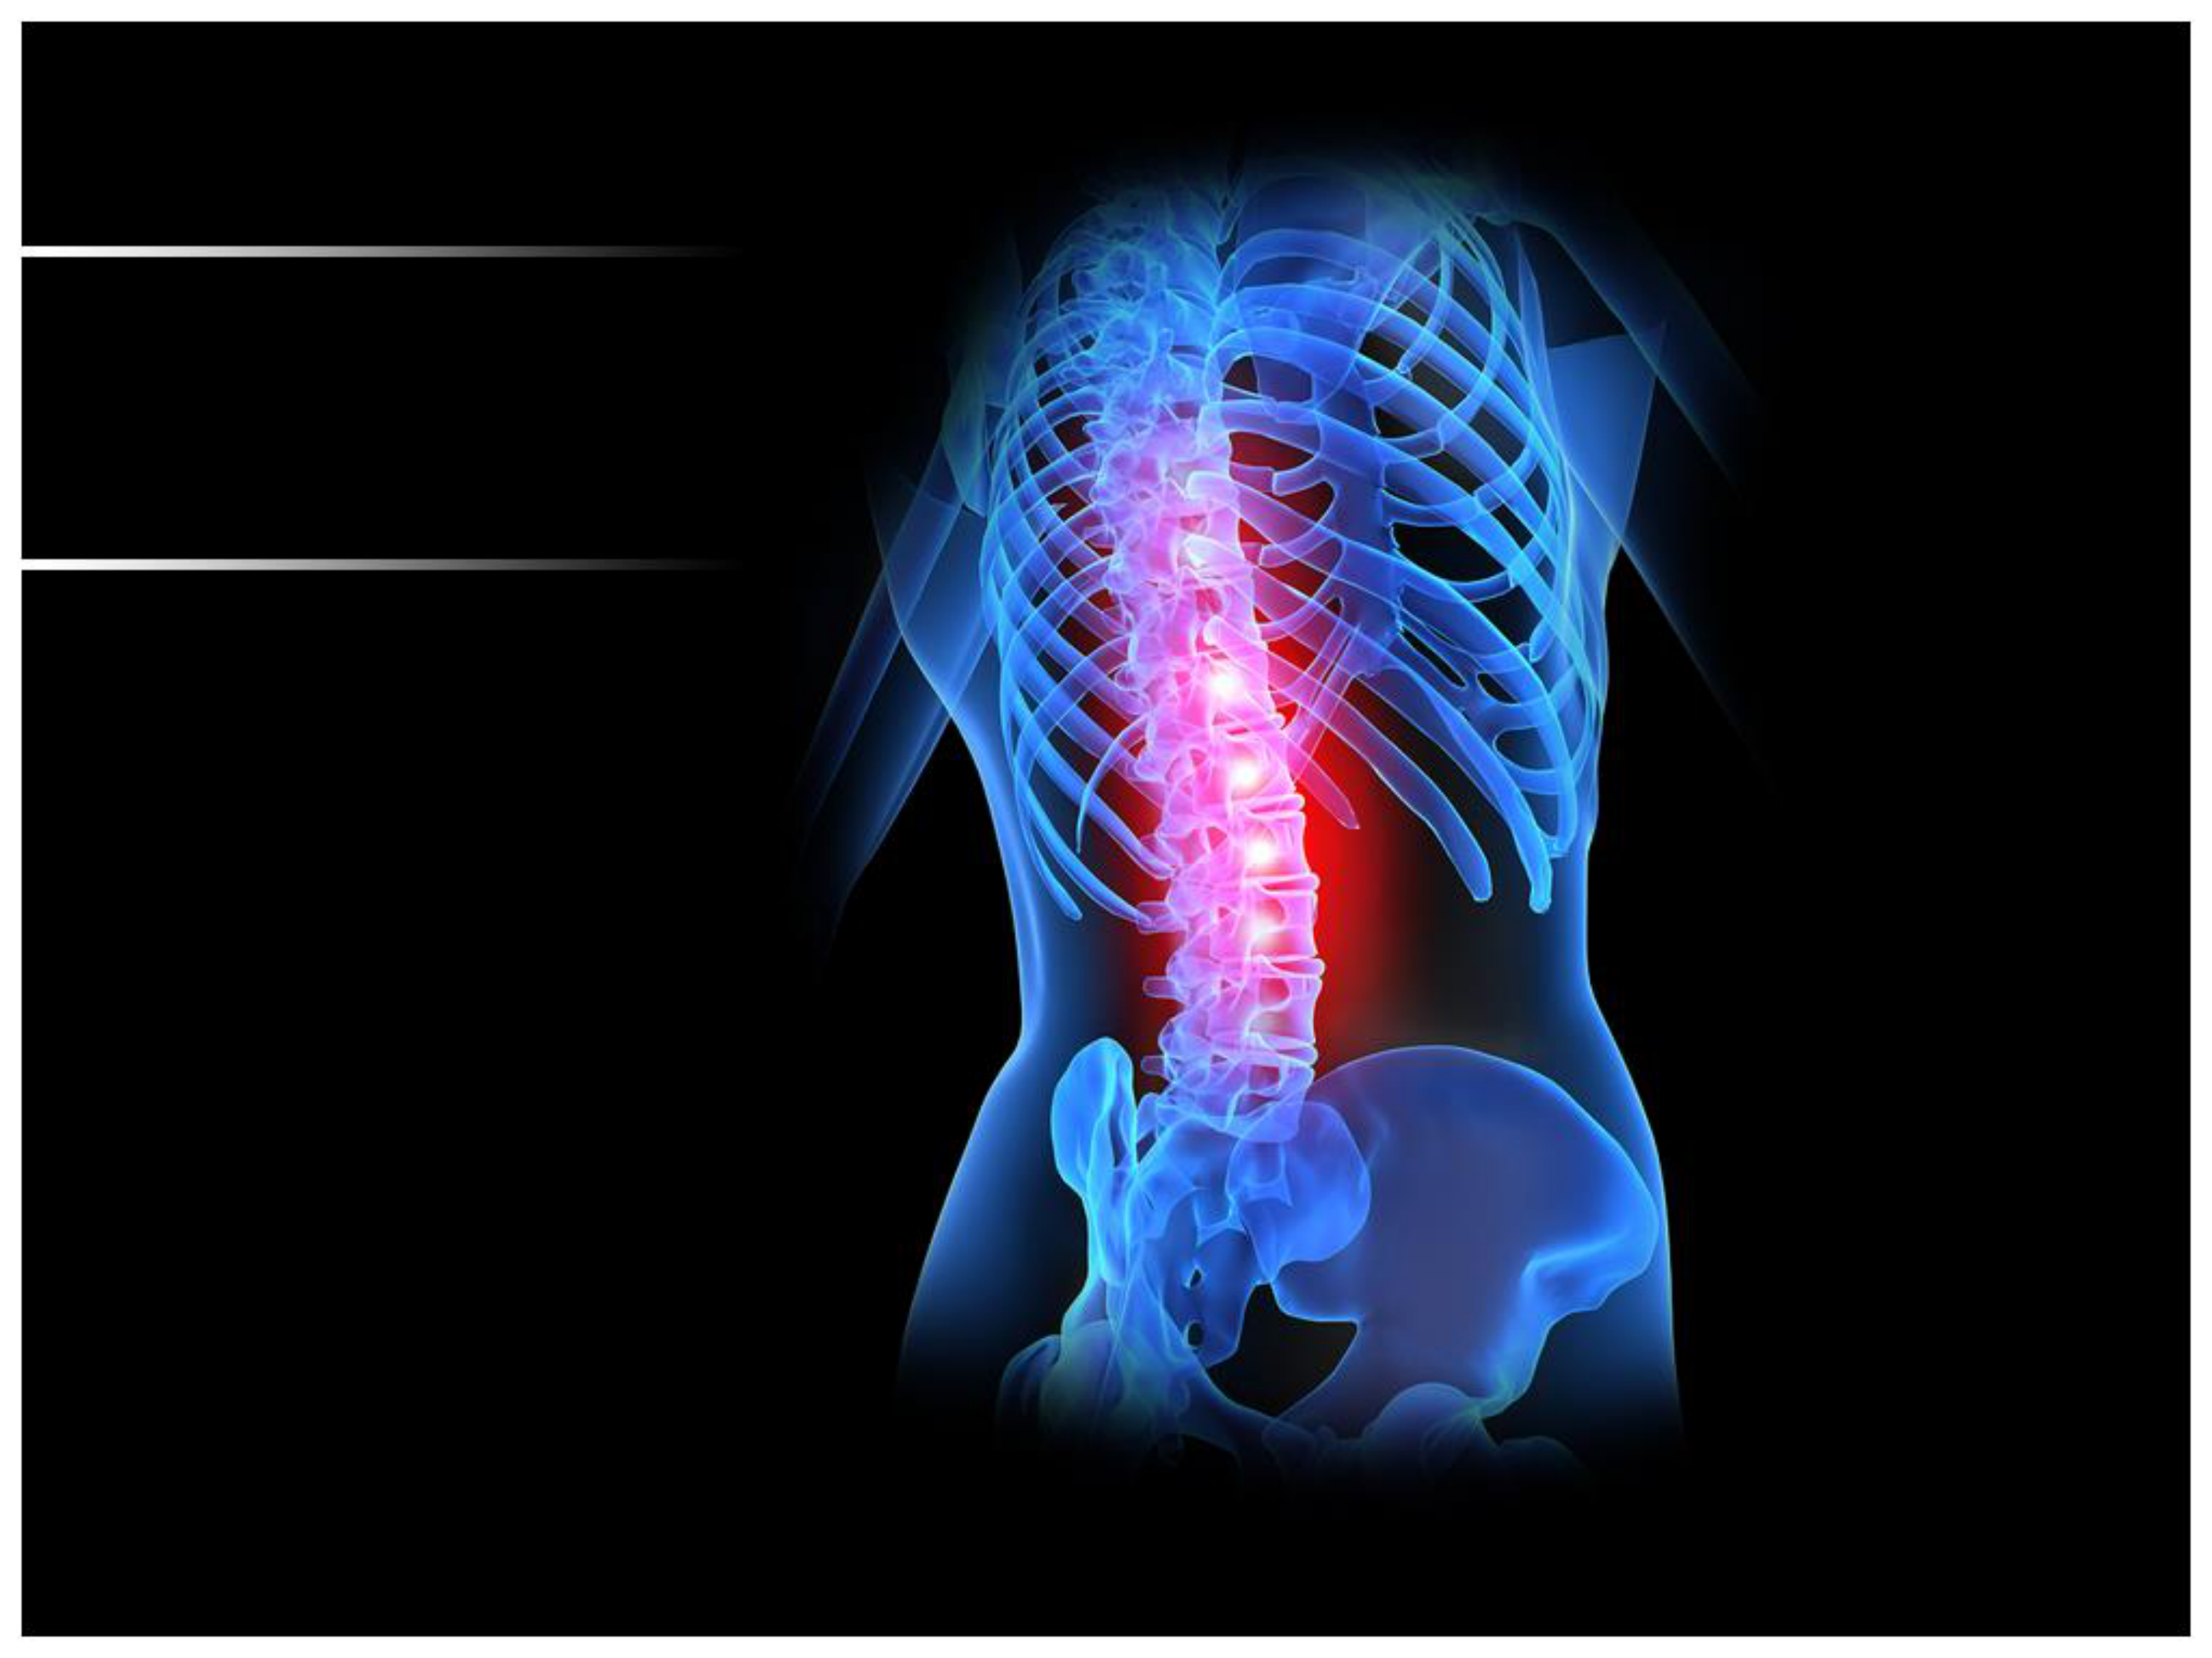

**BIOMECHANICS**   
 **OF CERVICAL**   
 **SPINE**

Dr. Faryah Aslam (PT)

MSAPT (DUHS), DPT (DUHS)

LECTURER

Jinnah University for Women

FILE CONVERTOR WEBSITE

1. Introduction   
This document outlines the complete requirements for developing a modern, fast, and user-friendly one-page website. The website will provide online document and image tools that allow users to convert, optimize, and manage files easily.

2. Project Objective   
The main objective of this project is to build a single-page web application that offers multiple document and image utilities in one place. The platform should be simple, attractive, and optimized for smooth user interaction.

3. Target Users

|  |  |
| --- | --- |
| • • • • | Students  Freelancers  Office and corporate users  Designers and content creators |

4. Website Features   
4.1 Document Converters   
 • PDF to Word and Word to PDF   
 • PDF to Excel and Excel to PDF   
 • PDF to PowerPoint and PowerPoint to PDF 4.2 Image Format Conversion   
 • PNG to JPG and JPG to PNG   
 • WEBP to JPG / PNG and vice versa   
4.3 Image Resizing & Optimization Tools

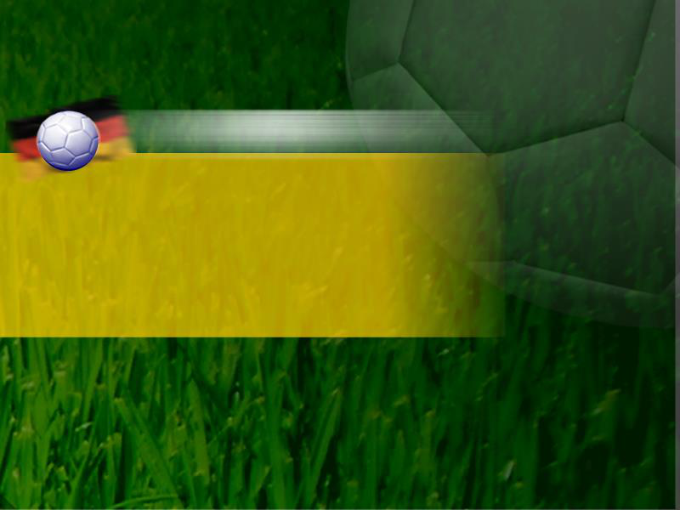

**Work Tests to Evaluate Cardiorespiratory Fitness**

Dr. Mahrukh (PT)   
DPT,MSAPT (Dow University of Health Sciences) Mahrukh.siddiqui@juw.edu.pk



**Objectives**

• Cardio respiratory fitness  
• Testing procedures  
• FIELD Tests for estimating CRF  
• Graded exercise tests: measurements• VO2 max  
• Graded exercise tests: protocols



**Testing Procedures**

•Sign consent form

•Screening  
 – PAR-Q and PARmed-X  
 – Classify individuals as low, moderate, or high risk

•Resting and exercise measures– HR and BP  
– Cholesterol  
– ECG  
– GXT or field test

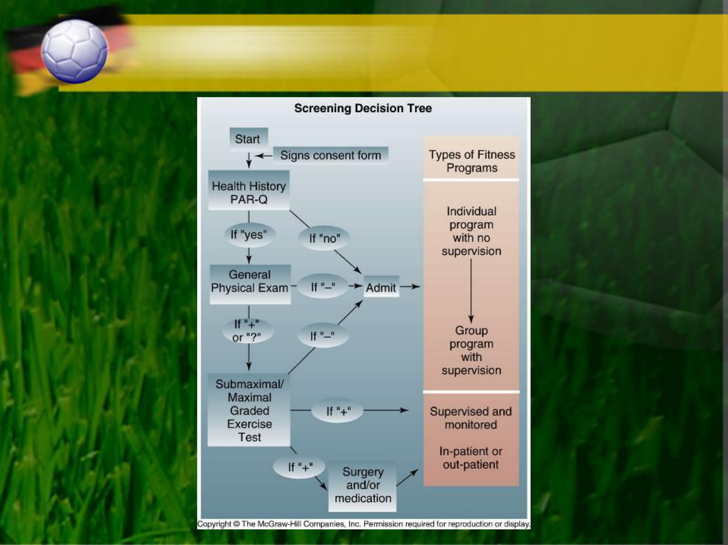

**Decision Tree in the Evaluation of Cardiorespiratory Fitness**



**Field Tests for Estimating Cardiorespiratory Fitness**

•Use natural activities  
 – Walking, running, or stepping  
•Can test large numbers of people at low cost•Physiological responses may be difficult to measure  
•Motivation plays an important role in test results



**Maximal Run Tests**

•Measure how far a person can run in a set time or how fast they can run a set distance  
 –Cooper’s 12-minute run and 1.5 mile run  
 •For adults  
 –AAPHERD’s 1-mile run/walk and PACER test  
 •For children  
•VO2max estimates based on the linear relationship between running speed and oxygen cost of running   
 –Duration of 10–20 minutes  
 •Running at speed demanding 90–95% VO2max  
 •Minimize contribution of anaerobic energy sources

**VO2 = 0.2 ml•kg-1•min-1 per m•min-1 + 3.5 ml•kg-1•min-1**

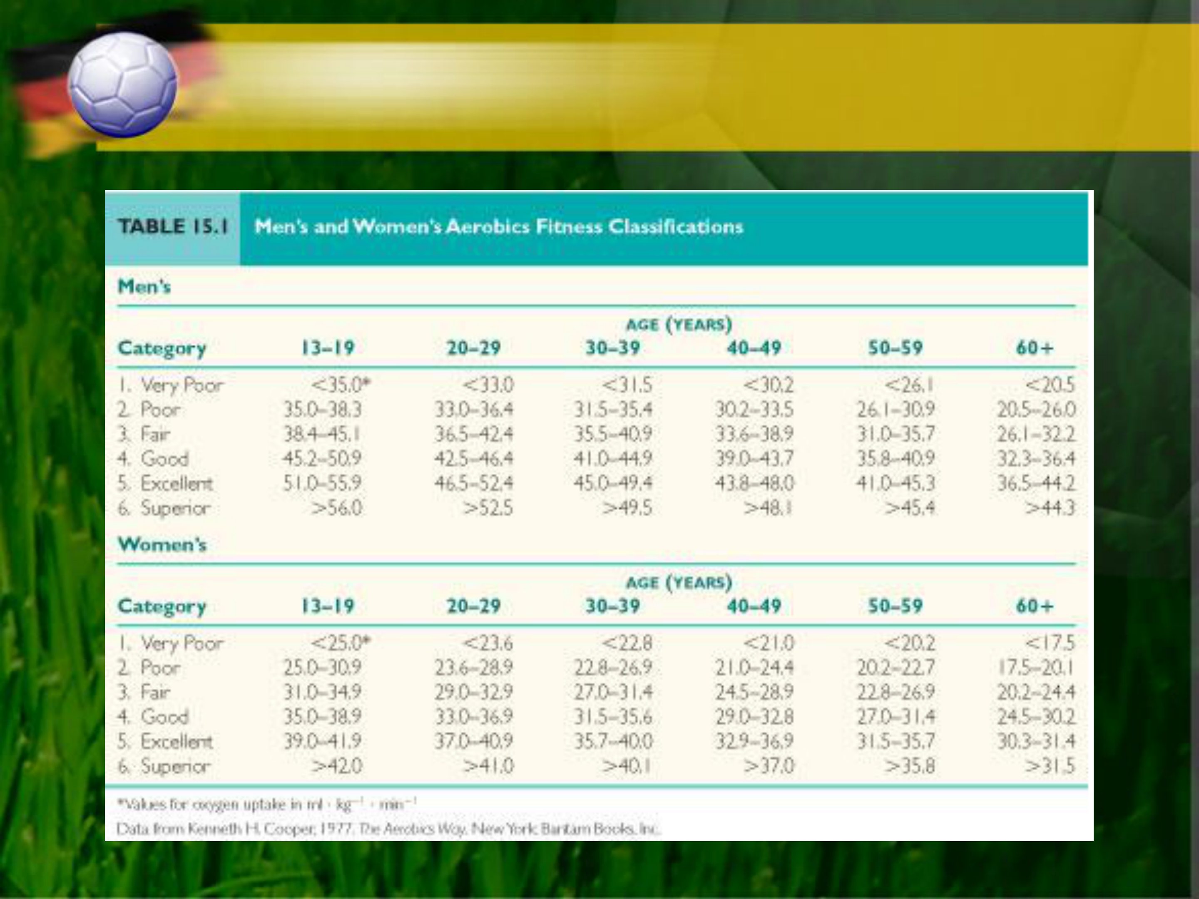

**Categories of VO2max Values**



**Walk Tests**

•One-mile walk test requires simple measurements  
•VO2max is based on:  
 –Age (years), weight (pounds), sex (0 for female, 1 for male), time (min), and HR (beats/min)

**VO2 (ml•kg-1•min-1) = 132.853 - 0.0769 (wt) - 0.3877 (age) + 6.315 (sex) - 3.2649 (time) - 0.1565 (HR)**

•As fitness improves, HR and/or time will be lower –Results in higher estimated VO2max



**Canadian Home Fitness Test**

•Uses 8-inch steps to evaluate cardiorespiratory fitness

•Measure HR after 3 minutes of stepping  
 – Stop if it exceeds maximum allowable HR based on age  
 – Continue for another 3 minutes if it is below maximum allowable HR  
 – Fitness level is based on post-exercise HR

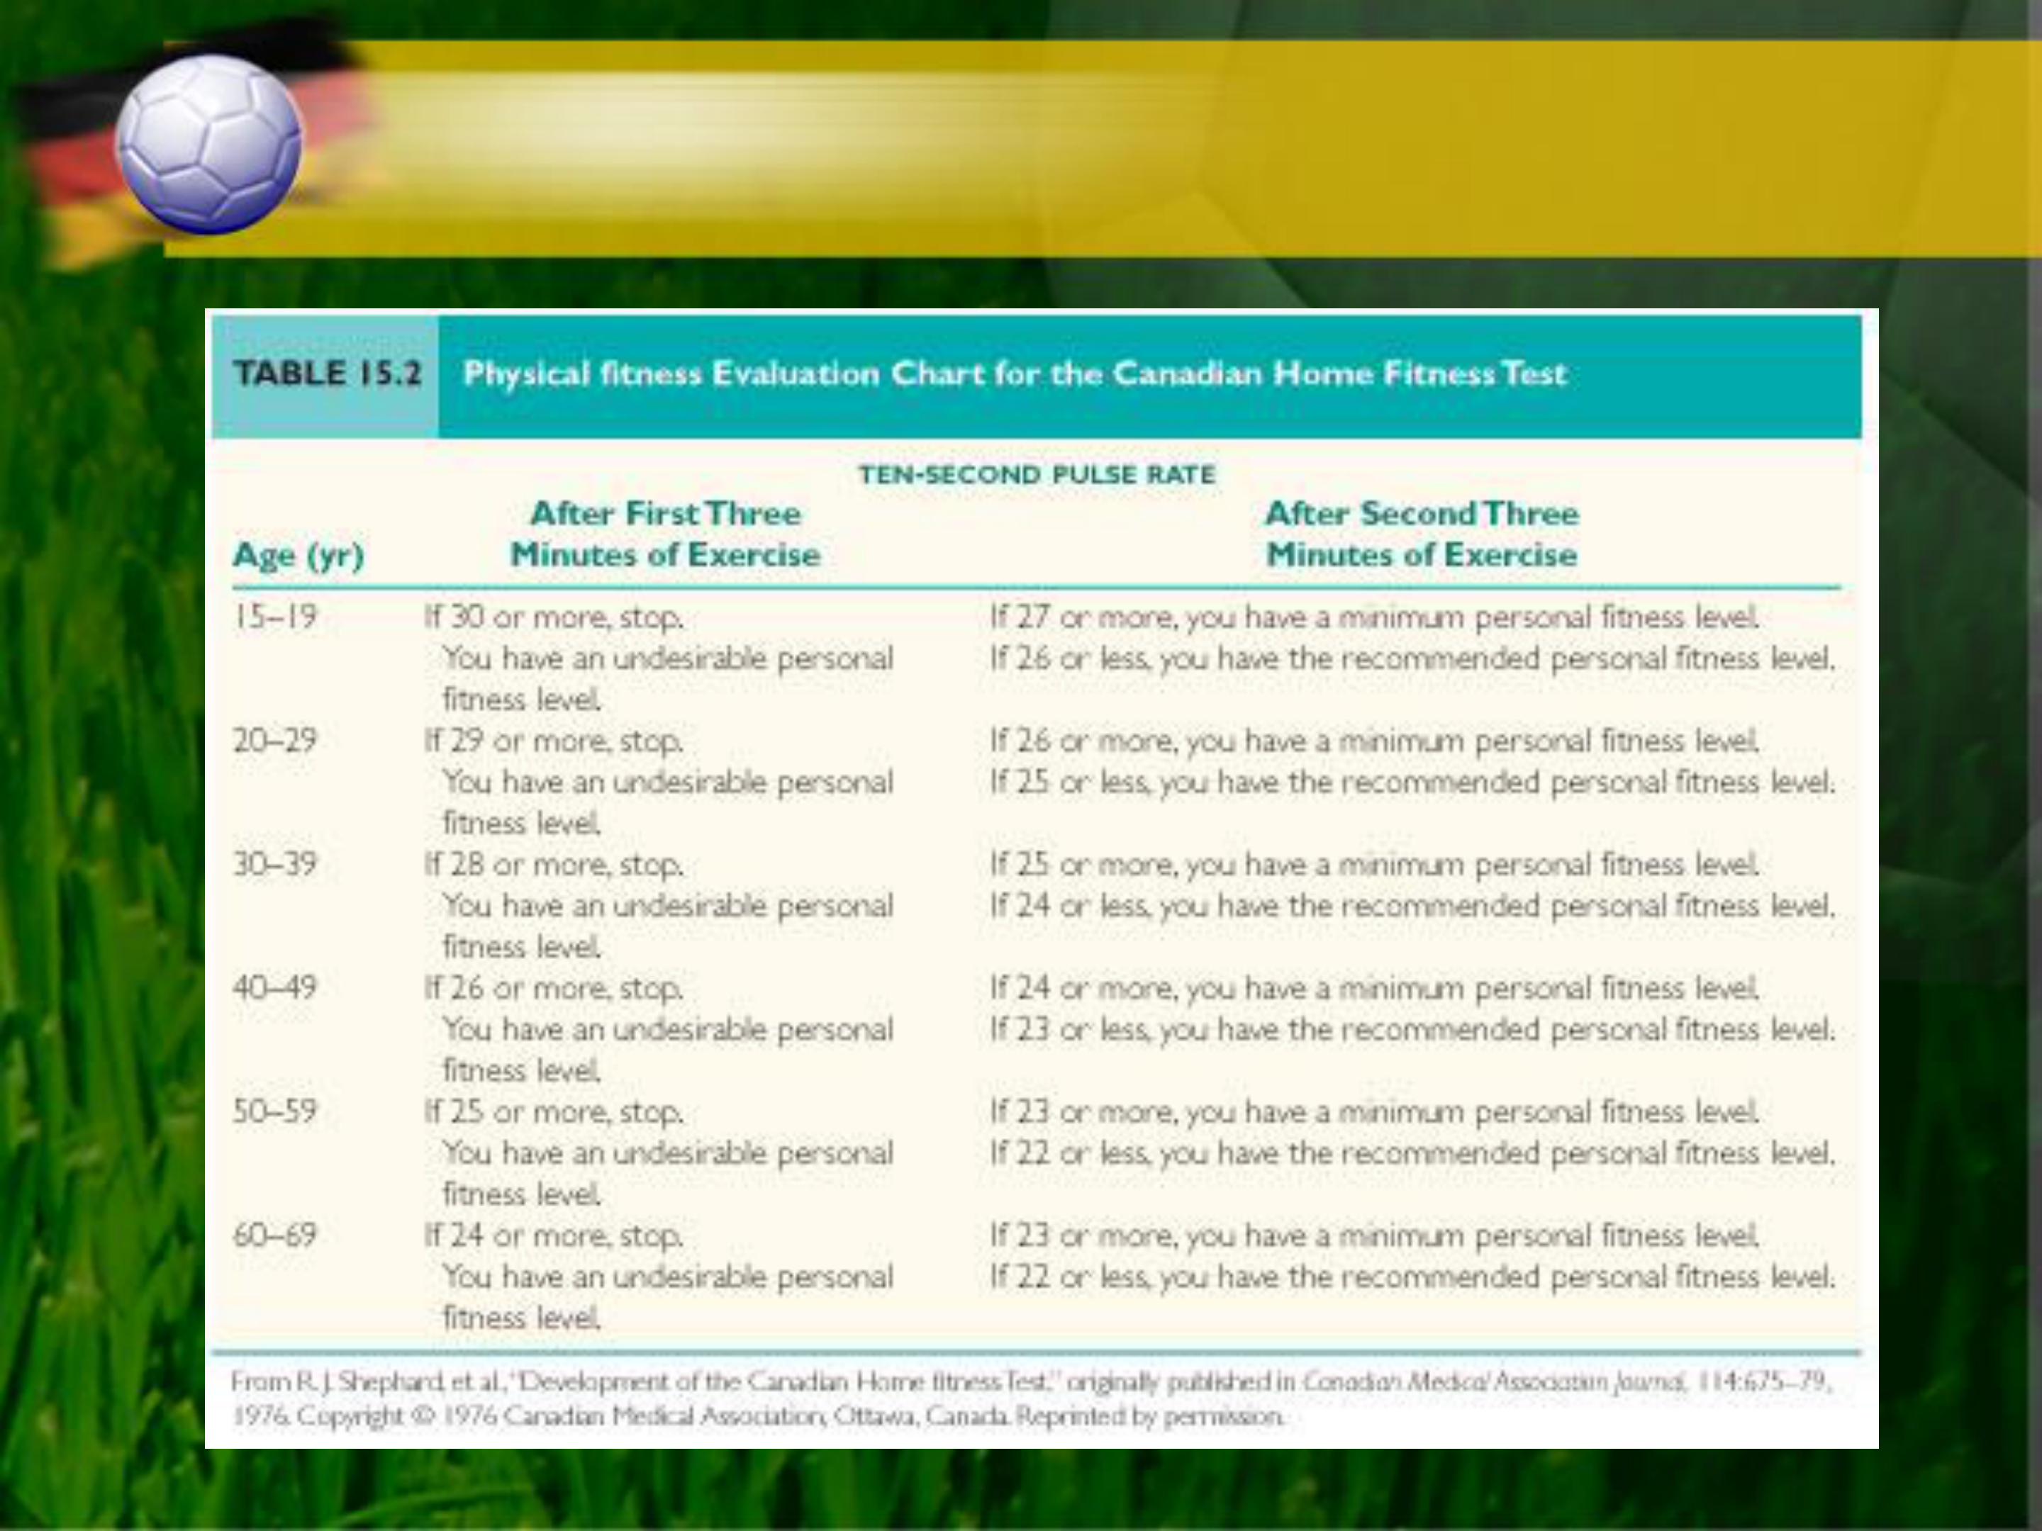

**Fitness Evaluation from the Canadian**  **Home Fitness Test**



**Graded Exercise Tests:**  **Measurements**

•Heart rate  
 –By palpation, stethoscope, ECG, or monitor   
•Blood pressure  
 –By auscultation  
•ECG  
 –Can diagnose arrhythmias or ischemia  
 •ST segment depression  
•Rating of perceived exertion (RPE)  
 –Subjective measure of fatigue  
•Termination criteria  
 –From ACSM’s *Guidelines for Exercise Testing and*  *Prescription*

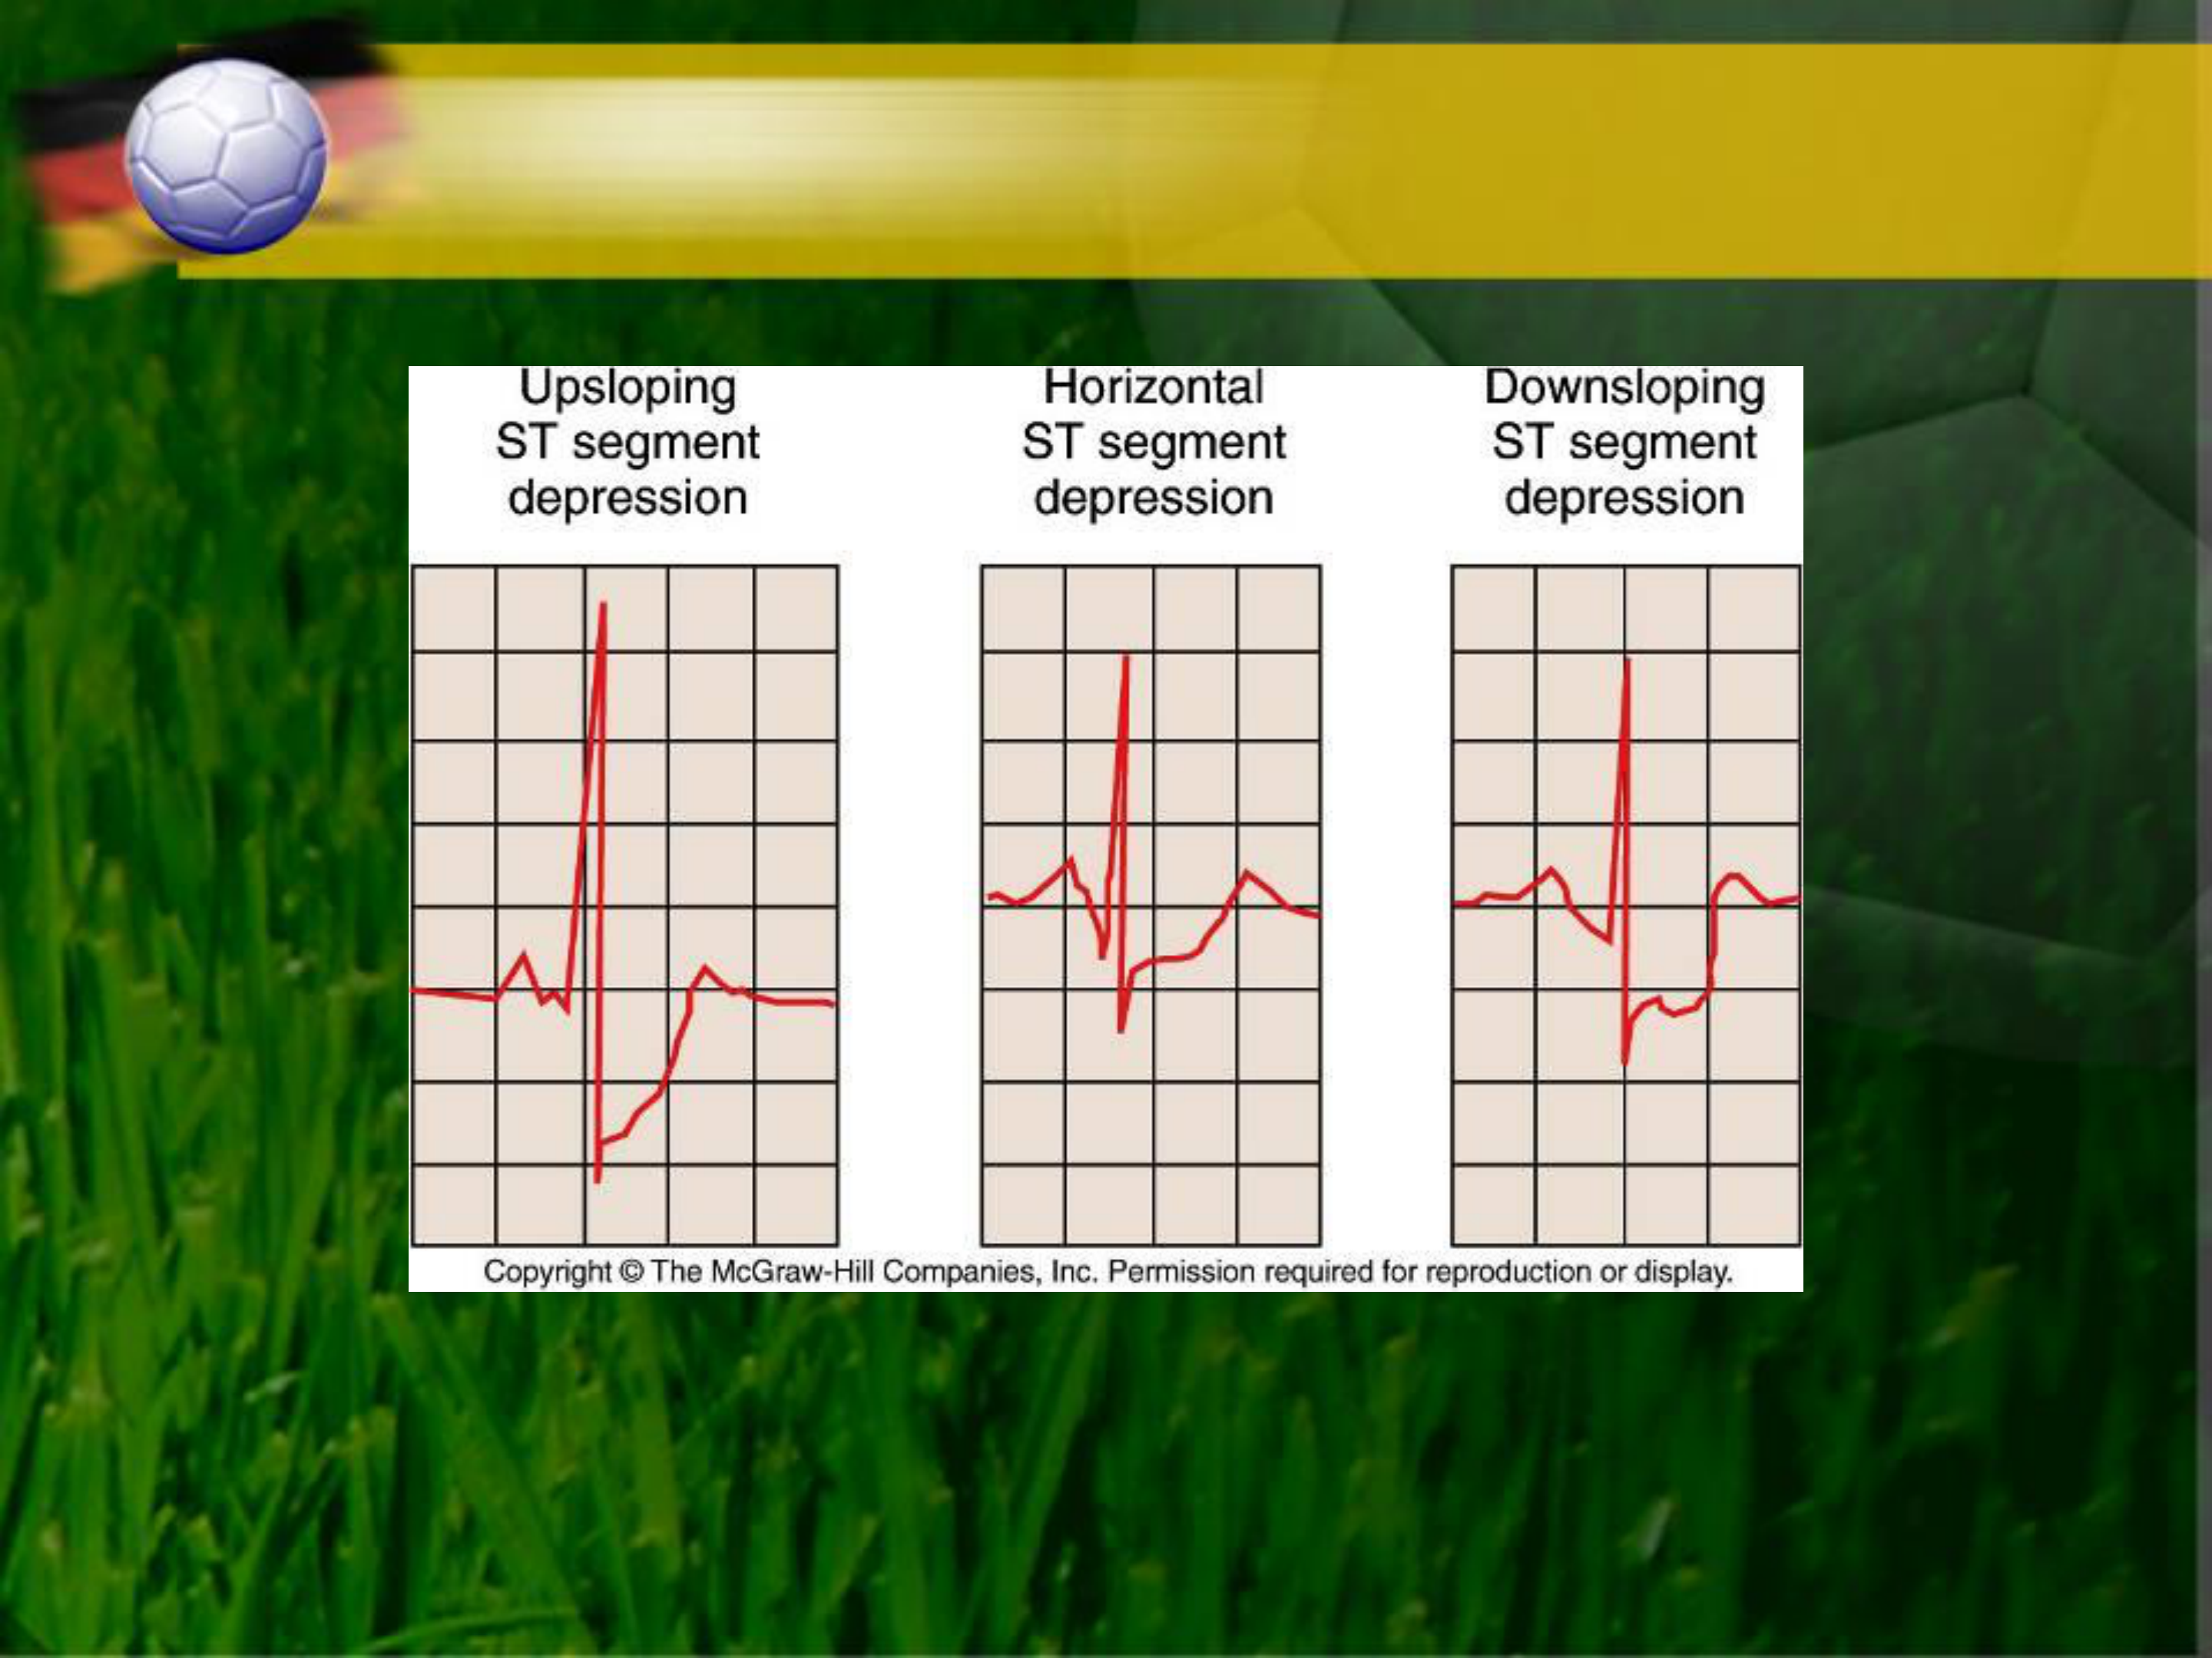

**Three Types of ST Segment Depression**

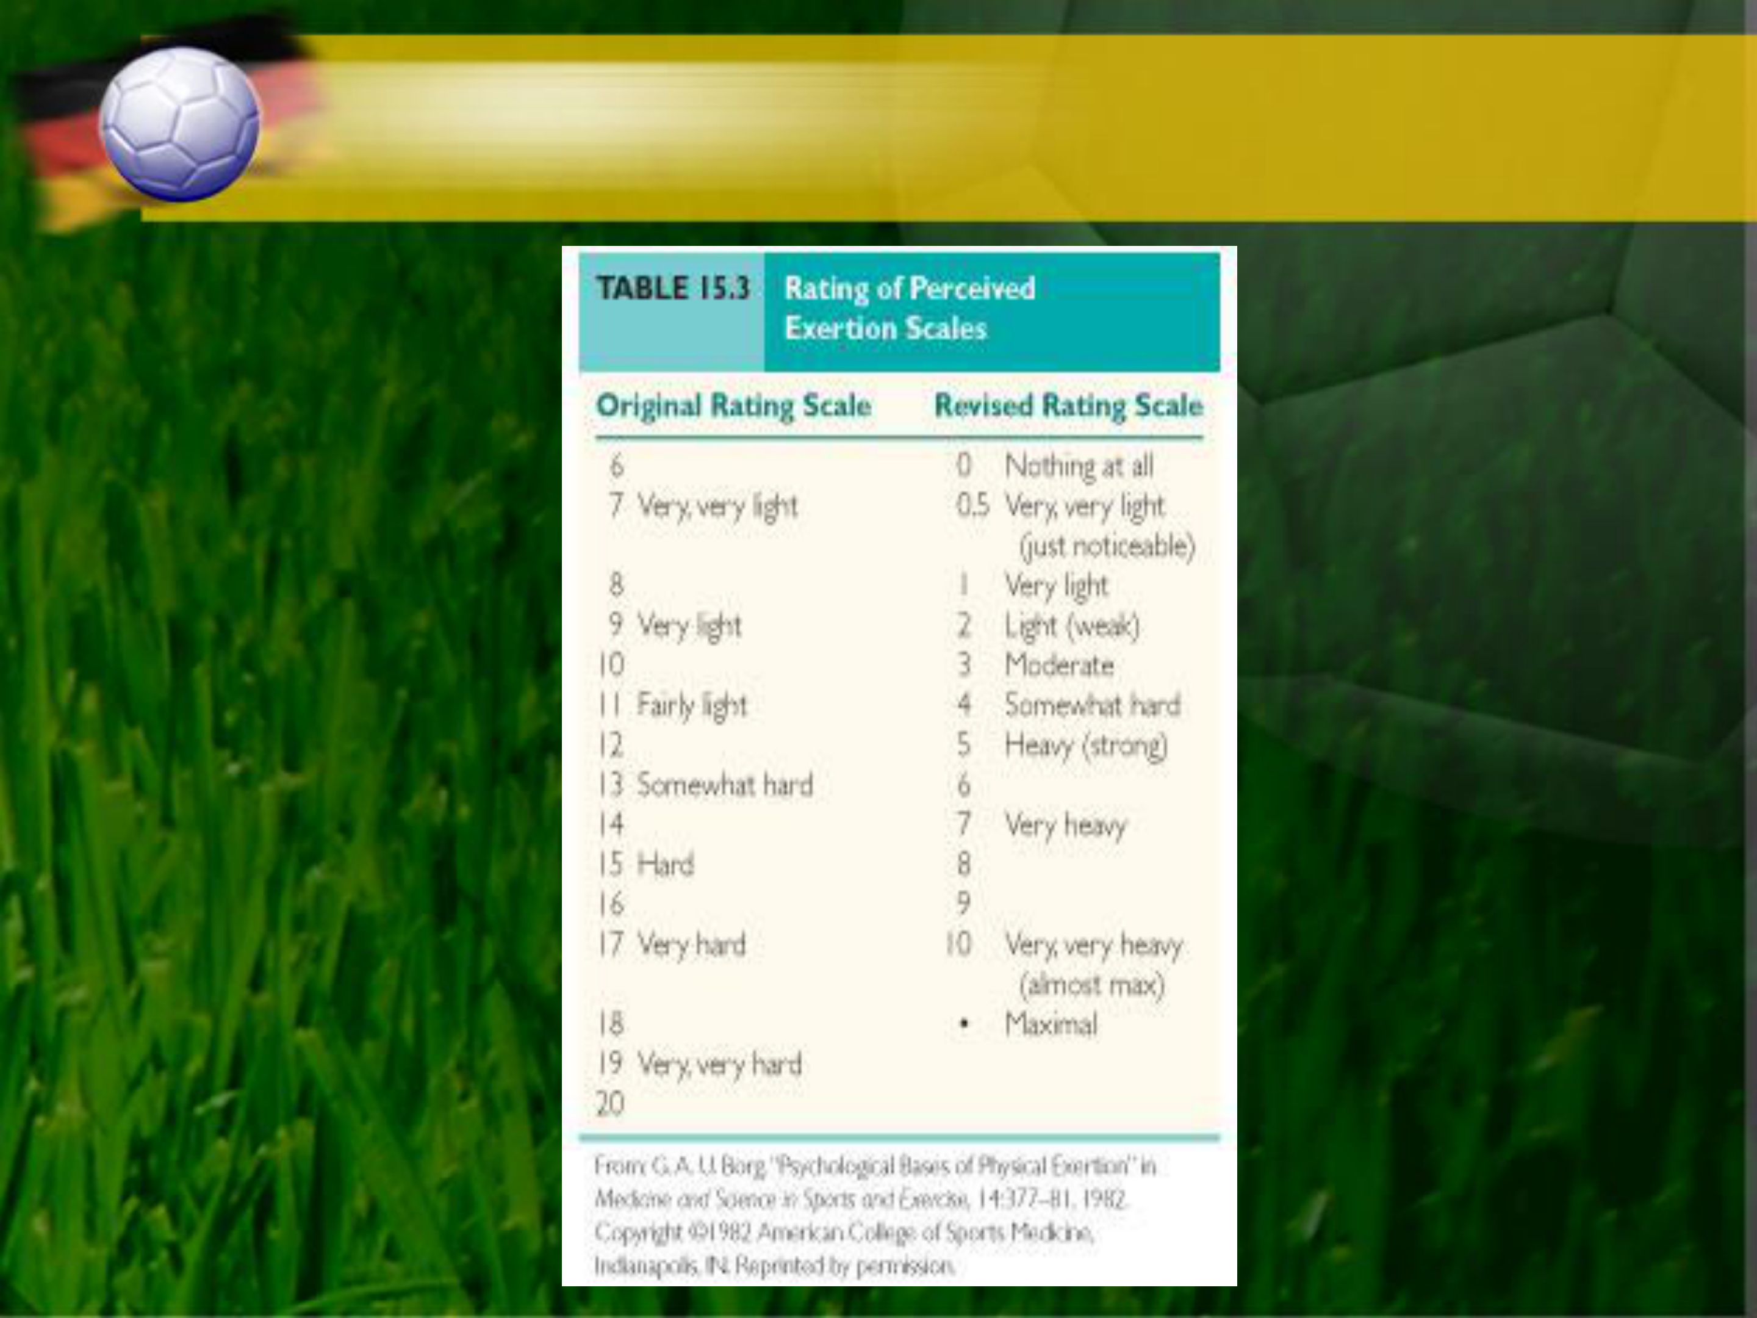

**Original and Revised RPE**  **Scales**



**GXT Termination Criteria**

• Onset of angina or angina-like symptoms  
• Drop in systolic blood pressure of >10mm Hg from baseline blood pressure despite an increase in workload  
• Excessive rise in blood pressure: systolic pressure>250mm HG or diastolic pressure >115mm HG  
• Shortness of breath, wheezing, leg cramps, or claudication  
• Signs of poor perfusion: light-headedness, confusion, ataxia, pallor, cyanosis, or cold and clammy skin  
• Failure of heart rate to increase with increased exercise intensity•  
 Noticeable change in heart rhythm• Subject requests to stop  
• Physical or verbal manifestations of severe fatigue  
• Failure of the testing equipment



**VO2 Max**   
•The gold standard measure of   
 cardiorespiratory fitness  
•Estimation from last work rate  
 – Use equations to calculate estimated VO2max

•Estimation from submaximal heart rate – Extrapolate measured submaximal HR to age-

predicted maximal HR to estimate VO2max

– Careful measurement of HR is required



**Estimation of VO2 Max From Last**  **Work Rate**

•Used in many fitness and clinical settings

•Subject should achieve steady-state in each stage

– Duration and rate of progression depends on fitness level

•Running:

**VO2 = 0.2 ml•kg-1•min-1 per m•min-1 + 3.5 ml•kg-1•min-1**

•Walking:

**VO2 = 0.1 ml•kg-1•min-1 per m•min-1 + 3.5 ml•kg-1•min-1**



**Estimation of VO2 Max From**  **Submaximal HR Response**

•The test is stopped when the subject reaches 85% of maximal HR

•A line is drawn through the HR points   
measured during the test and is extrapolated to the age-adjusted estimate of maximal HR

•Another line is dropped down from that point to the x-axis, and the VO2max is identified

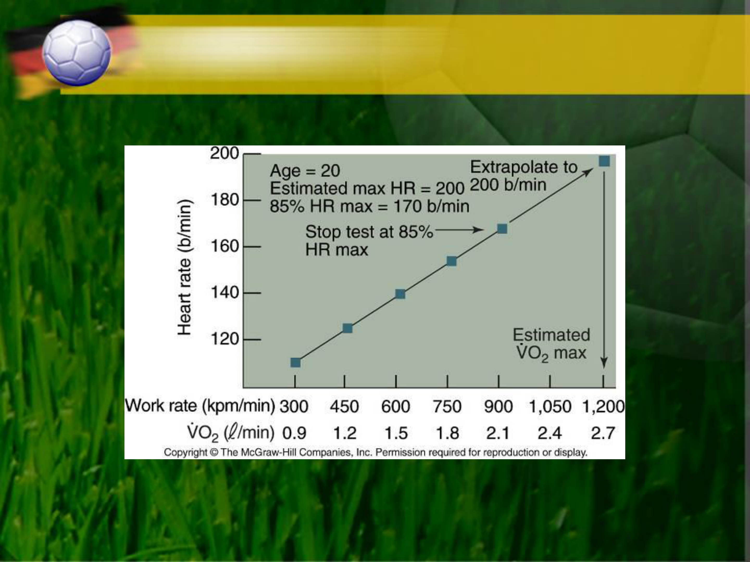

**Estimation of VO2 max From Submaximal**  **Cycle Ergometer Test**



**Graded Exercise Test: Protocols**

•Consideration of the population tested  
 – Submaximal vs. maximal test  
 – Starting work rate  
 – Rate of change of work rate  
 – Mode of exercise  
 •Treadmill  
 •Cycle ergometer  
 •Step test  
•Subjects must follow instructions carefully•Environmental conditions must be controlled – Temperature and humidity

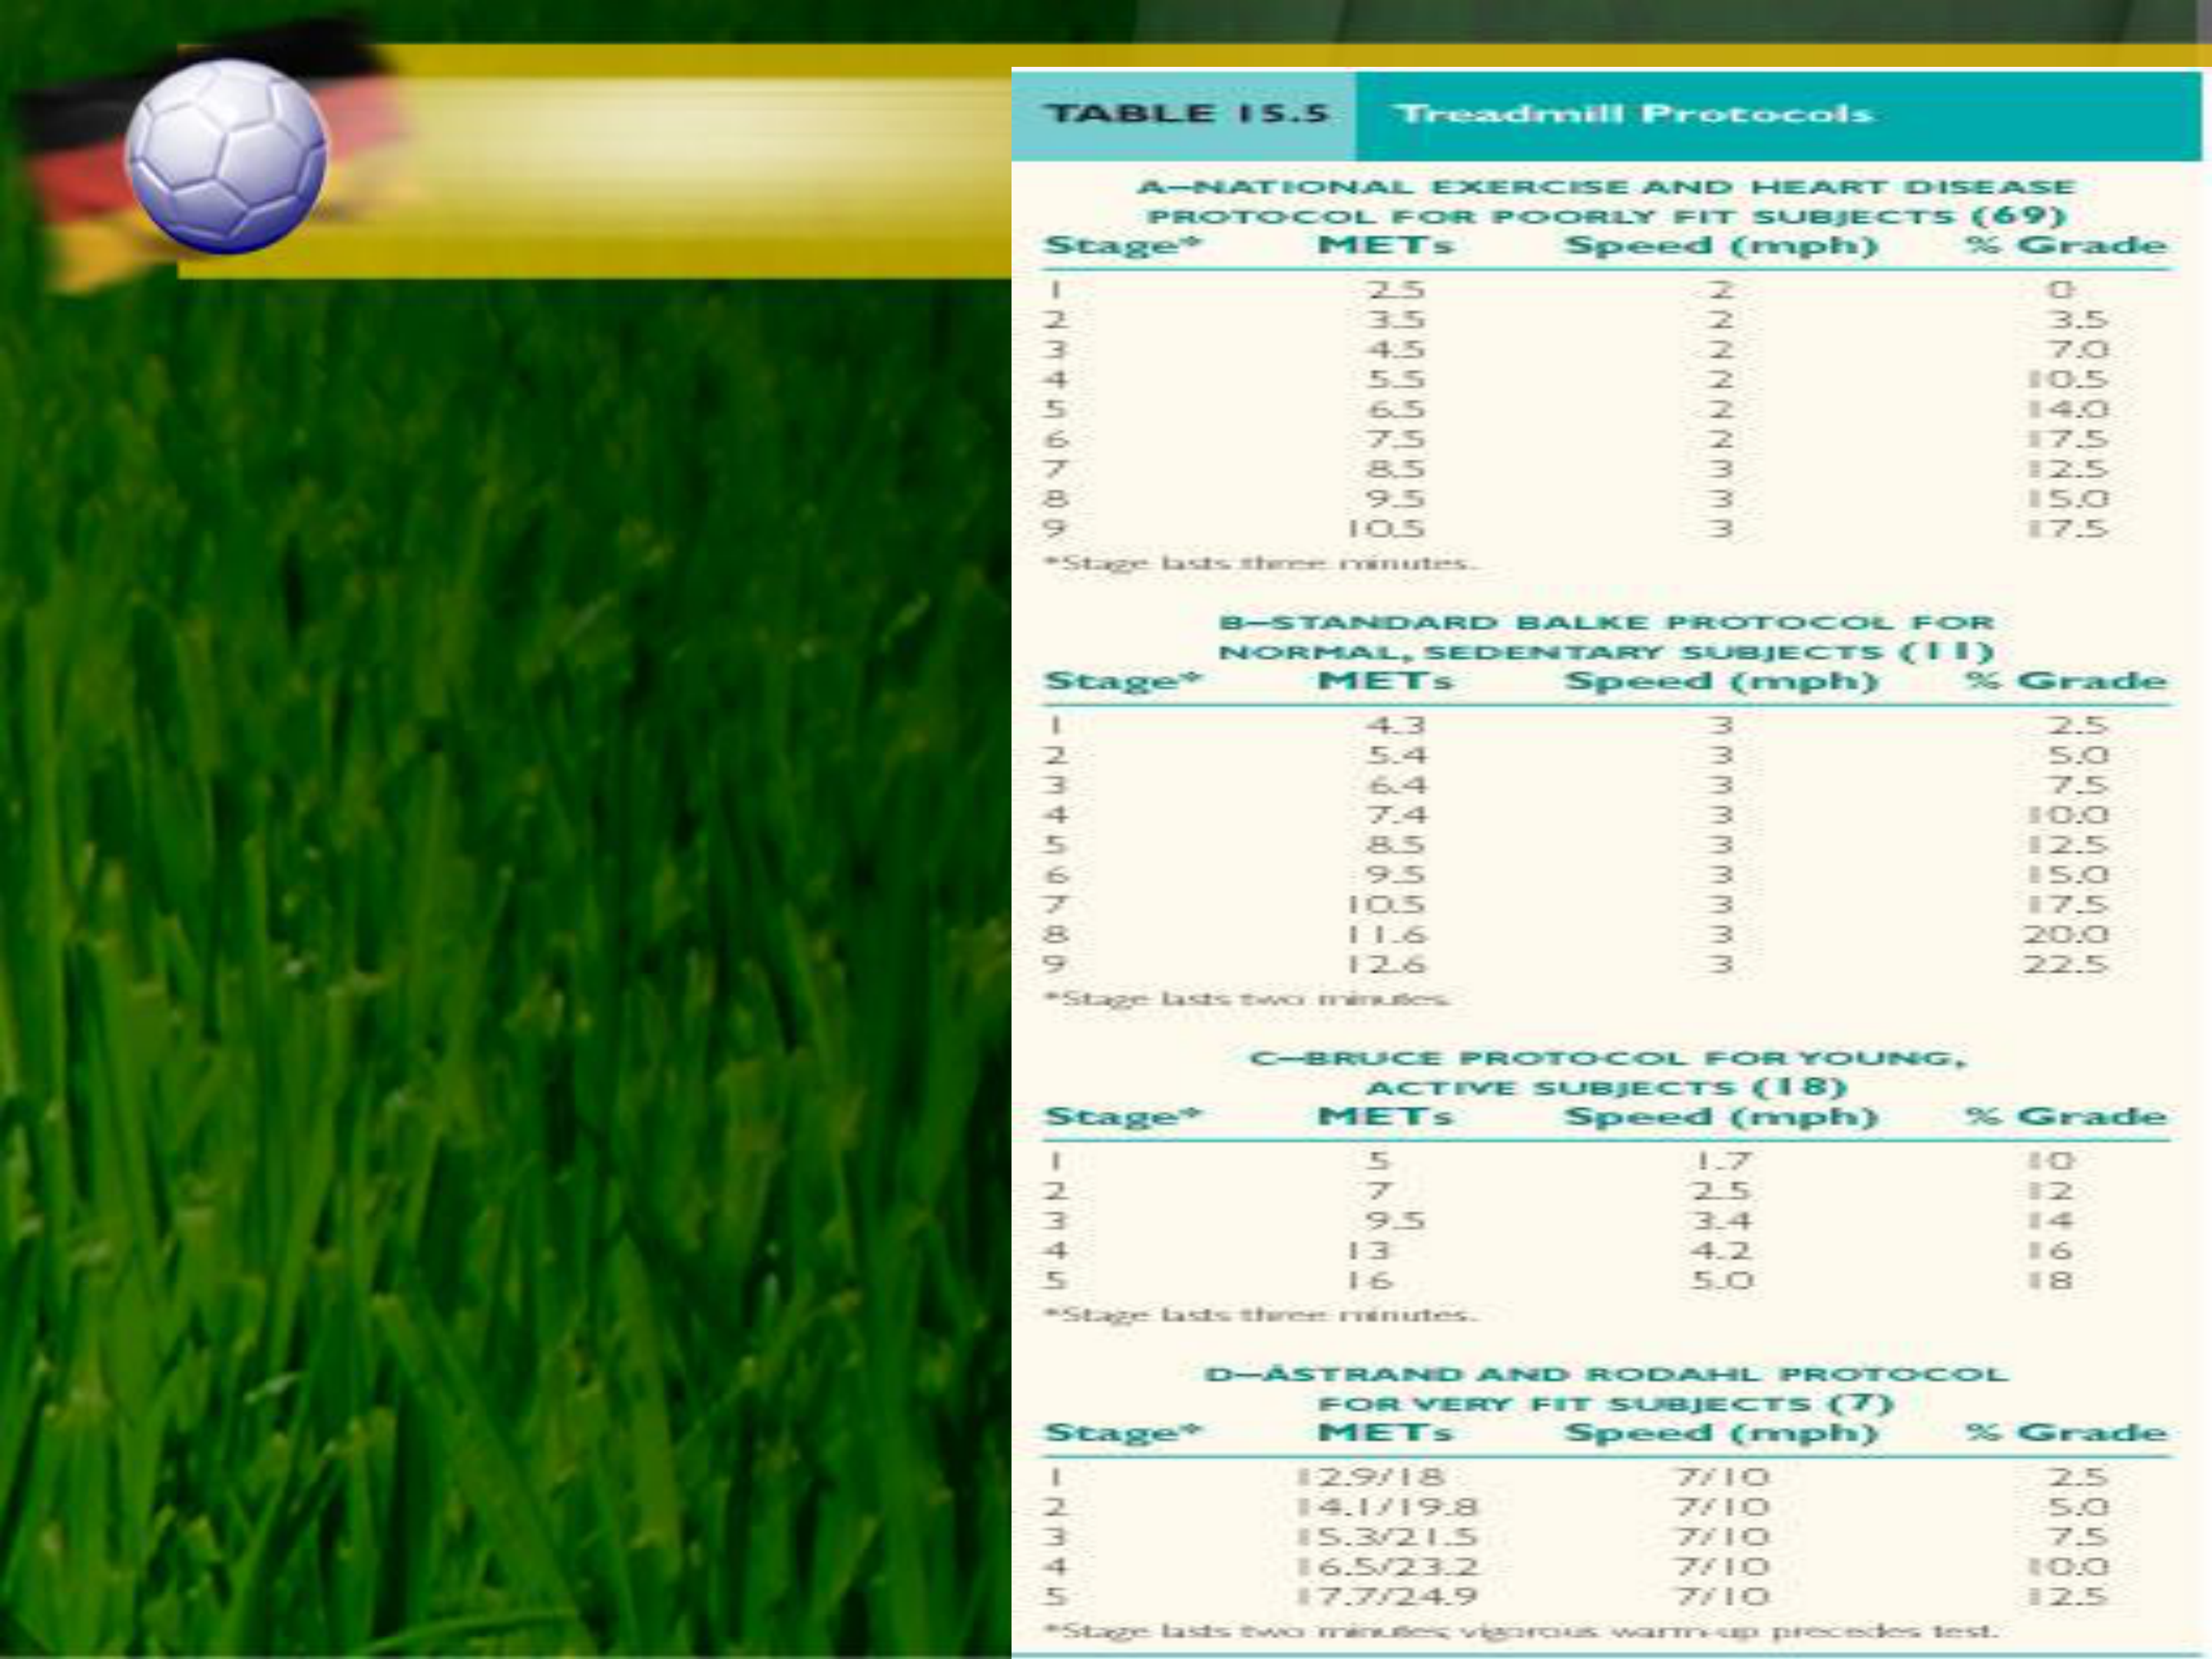

**Treadmill GXT**   
 **Protocols**



**Treadmill**

•Use natural activities  
 – Walking and running  
•Can accommodate a wide range of subjects – Least fit to most fit  
•Involve increasing speed and/or grade

•Estimating VO2max  
– Usually based on extrapolating submaximal HR– Could also be a single-stage test

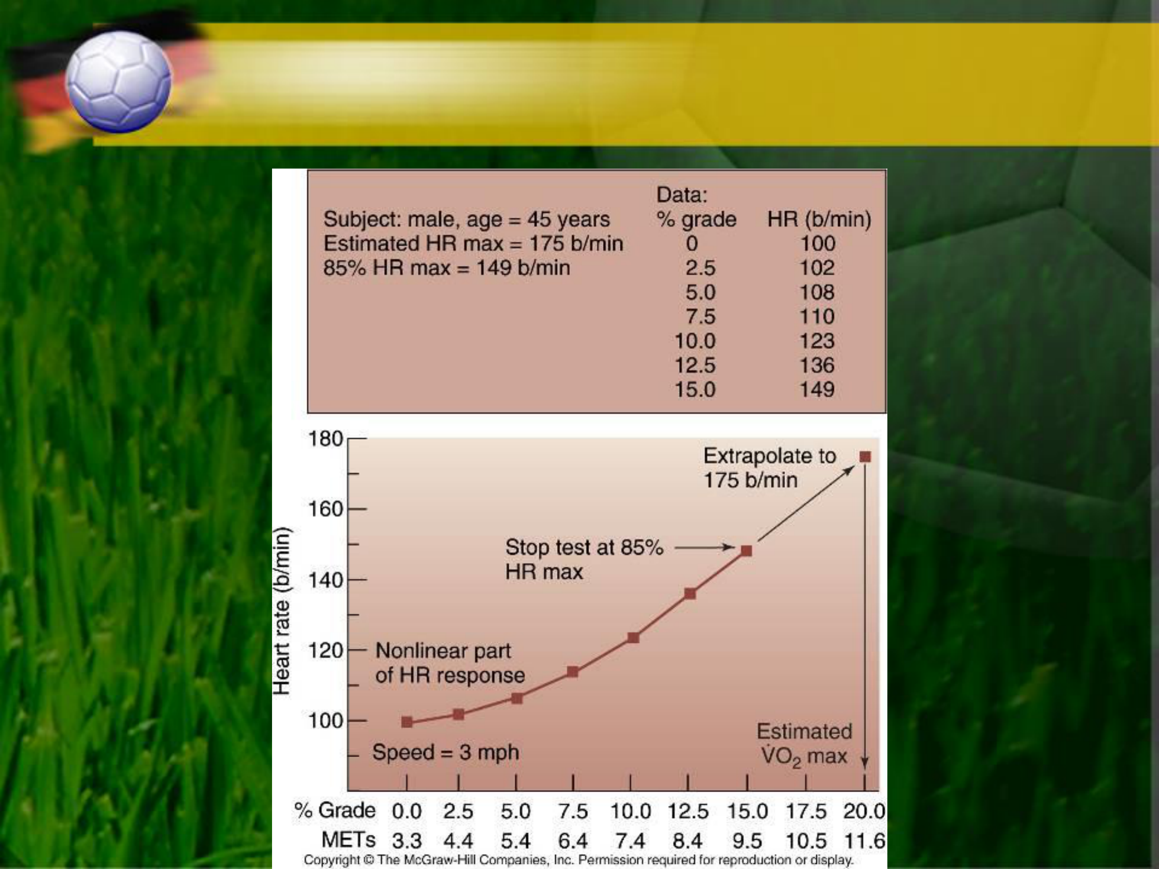

**Estimation of VO2 Max From Submaximal Treadmill Test**



**Cycle Ergometer**

•Body weight is supported

– Can accommodate subjects with orthopedic limitations

•Work rate depends on resistance and pedal rate

– Generally, pedal rate is maintained, and resistance is increased

•Estimating VO2max

– Based on extrapolating submaximal HR during incremental test

•YMCA protocol

– From a single stage, 6-minute test

•Åstrand and Ryhming nomogram

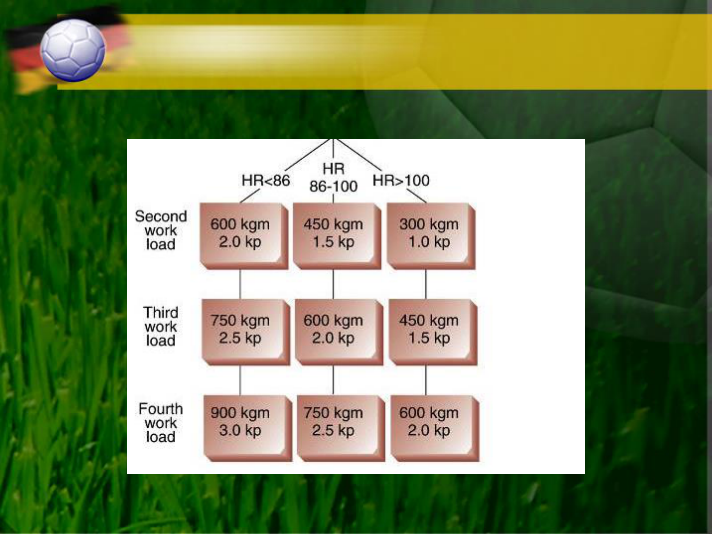

**YMCA Protocol**

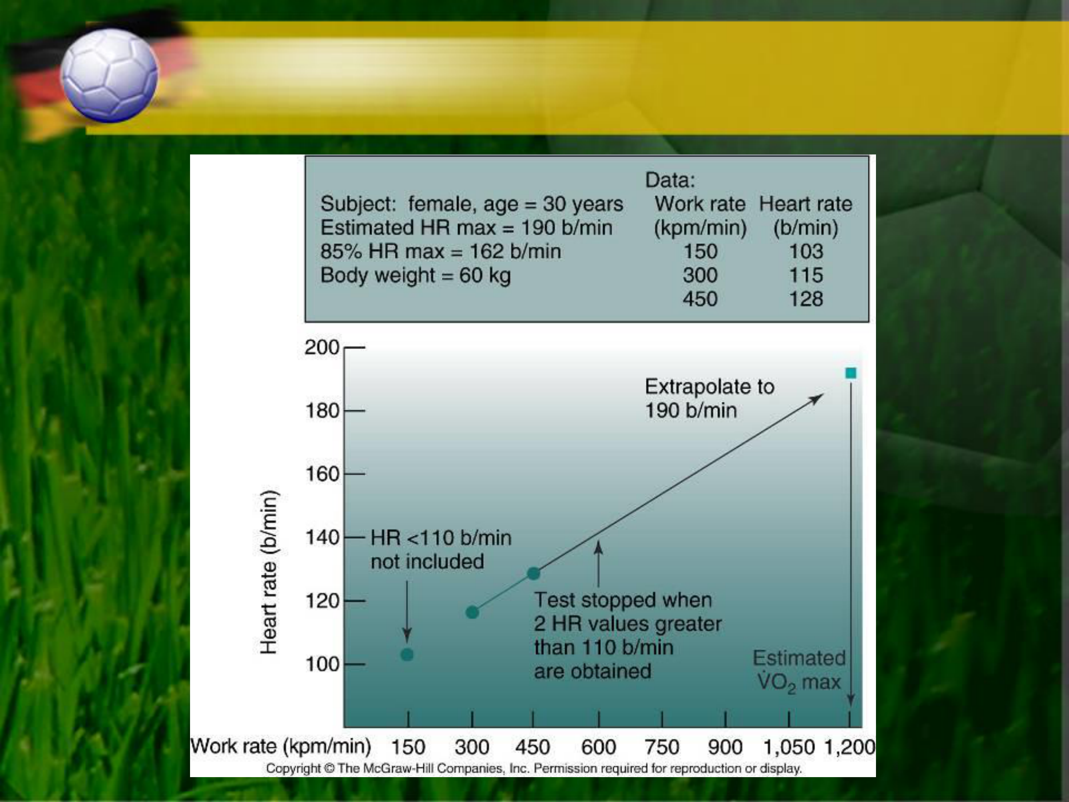

**Example of the YMCA Protocol Used**  **to Estimate VO2 max**

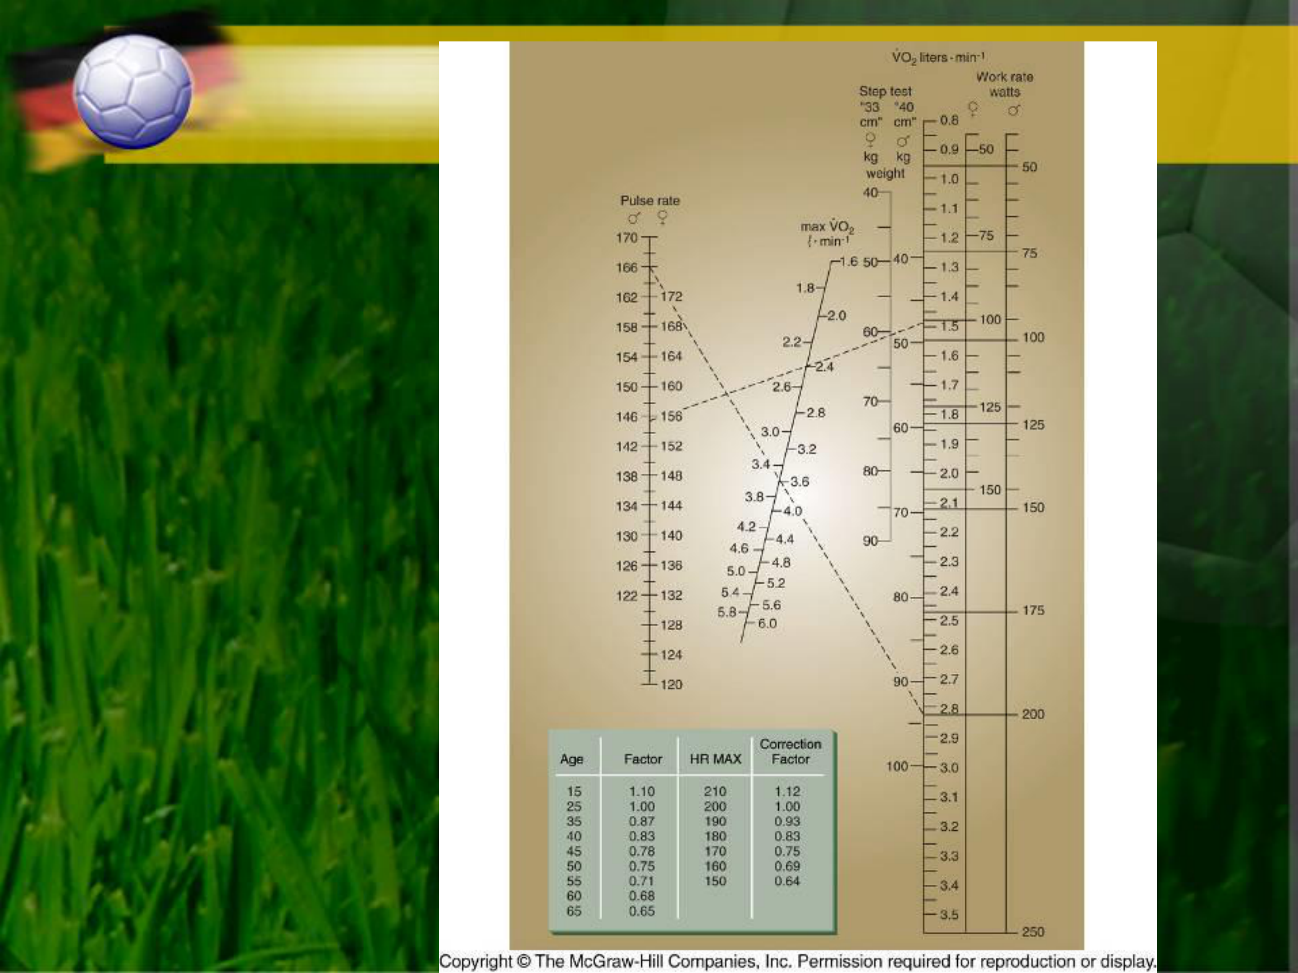

**Nomogram for**   
**Estimation of**   
**VO2 max from**   
**Submaximal**

**HR**



**Step Test**

•Simple, inexpensive equipment

•Protocols differ in:  
– Step height  
– Step rate

•Estimating VO2max  
– Based on extrapolating submaximal HR  
– Can also use Åstrand and Ryhming nomogram

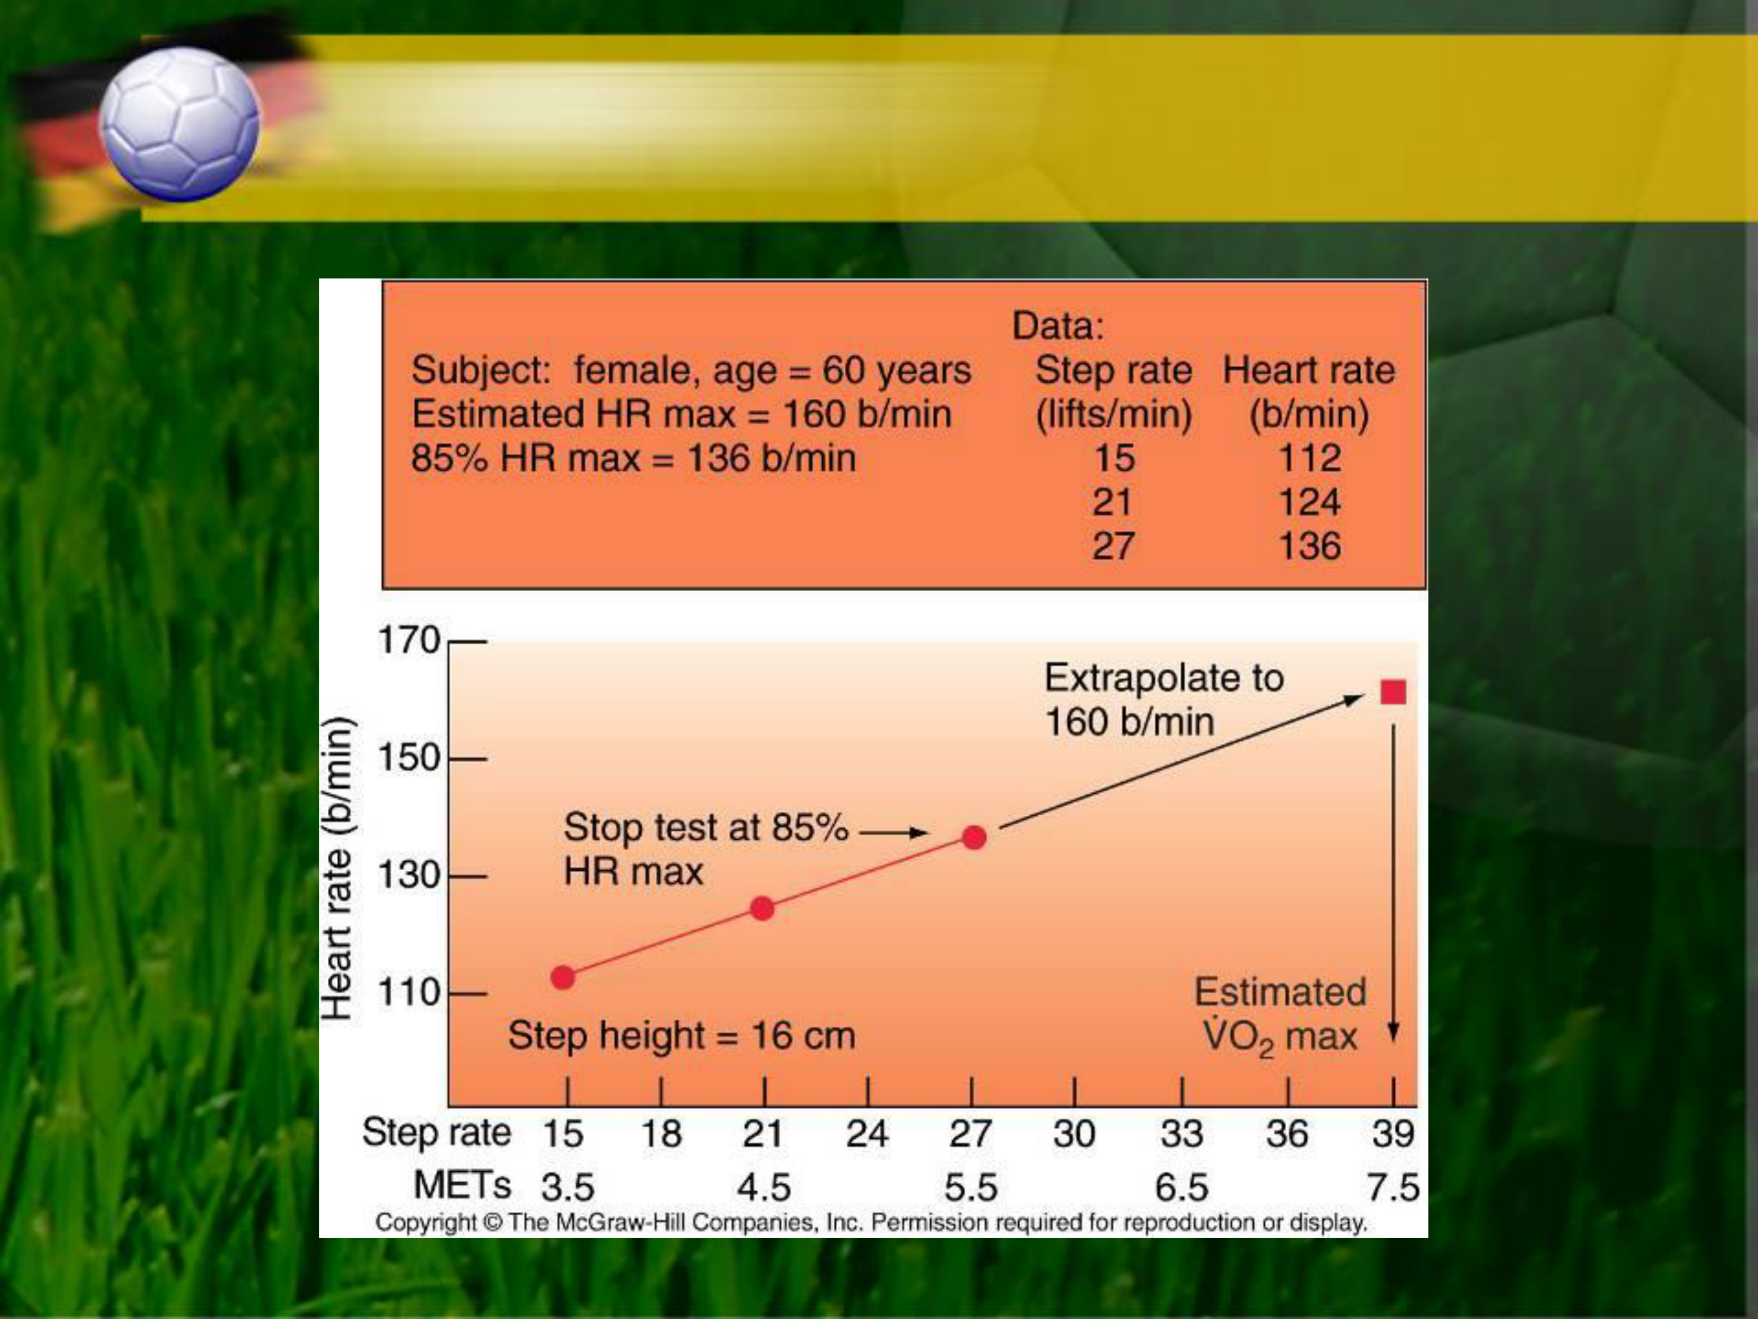

**Predicting VO2 Max From Submaximal Step Test**





**Reference**   
Theory and Application to Fitness and Performance, 6th edition

Scott K. Powers & Edward T. Howley